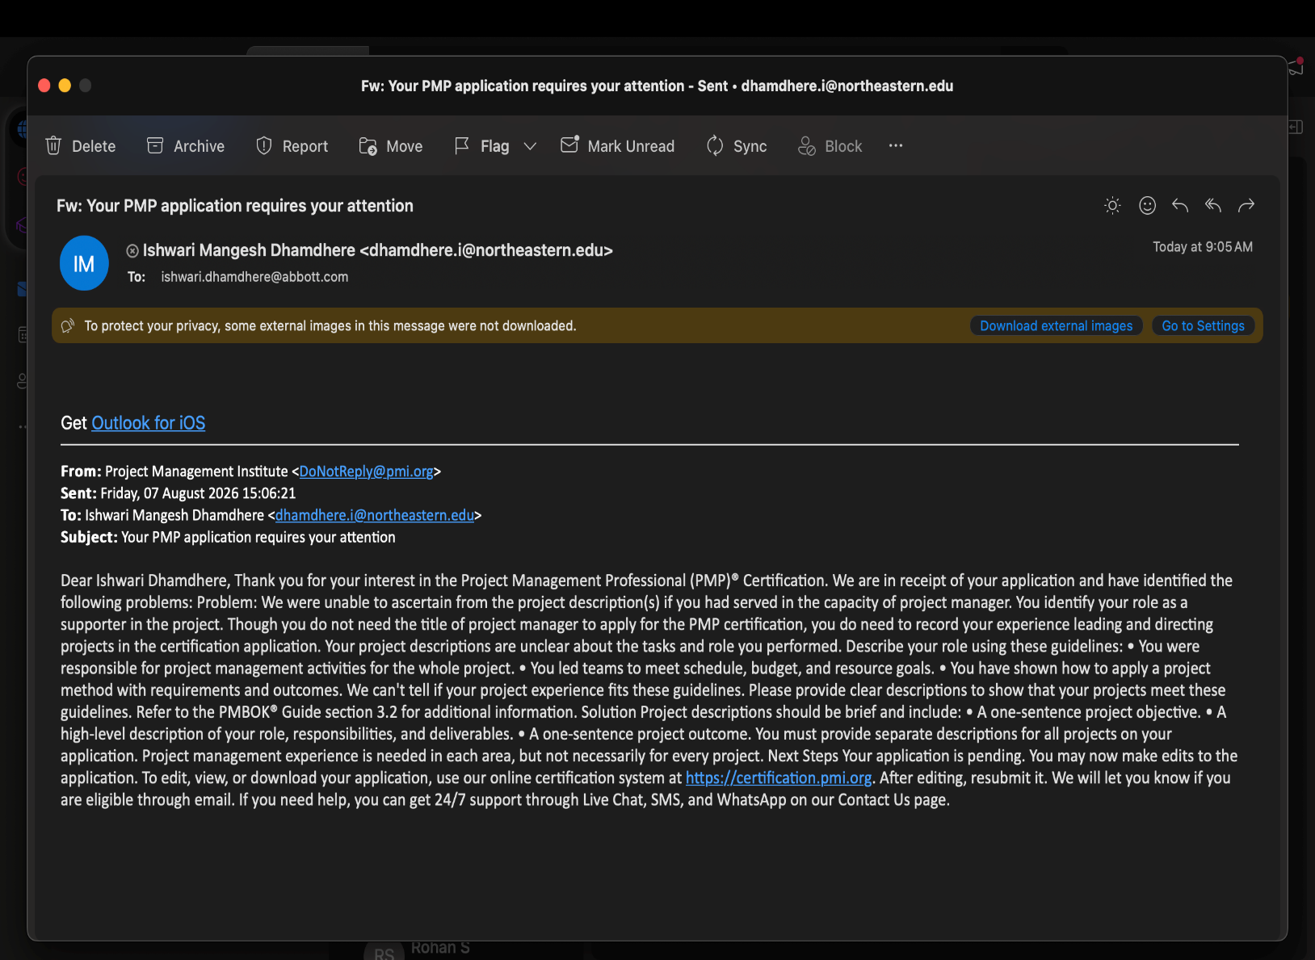PMP Application

New Jersey City University
Project Assistant Jan 2023- May 2023
Supported the execution of university admissions outreach initiatives by coordinating student engagement activities, campus tours, recruitment events, and orientation programs.
Collaborated with admissions staff and university stakeholders to plan event activities, manage schedules, coordinate resources, and ensure successful delivery of prospective student engagement initiatives.
Managed communication with prospective students, families, and internal teams to gather requirements, address inquiries, and ensure alignment with admissions objectives.
Assisted in tracking event participation, maintaining accurate records, and providing status updates to support operational decision-making. Identified and resolved scheduling and logistical challenges during events while ensuring a positive stakeholder experience.
Contributed to continuous improvement of admissions processes by collecting feedback, supporting workflow improvements, and helping optimize student engagement activities. This experience strengthened skills in stakeholder management, communication, coordination, risk identification, and execution of structured initiatives within a fast-paced environment.

Northeastern University
Project Manager Sept 2023 - Dec 2023
Project Title: Enphase PowerOwl Residential Energy Storage Solution Project
Led a graduate project focused on developing a comprehensive project management plan for the Enphase PowerOwl residential energy storage solution
Managed project planning activities including defining project scope, developing a Work Breakdown Structure (WBS), creating a Microsoft Project schedule, establishing milestones, analyzing task dependencies, and allocating resources to support successful project execution.

Coordinated cross-functional project planning across engineering, product development, manufacturing, quality, and operations stakeholders to align project objectives, deliverables, timelines, and resource requirements
Applied project management methodologies including critical path analysis, schedule optimization, risk identification, and dependency management to improve project visibility and execution readiness.
Developed project documentation including project schedules, milestone tracking plans, risk considerations, and resource management strategies.
Monitored project progress against planned timelines, identified potential schedule risks, and recommended mitigation strategies to support timely delivery of the renewable energy solution.
Successfully applied project management principles across project lifecycle phases, demonstrating skills in scope management, schedule management, resource planning, stakeholder communication, risk management, and project execution.

Northeastern University
Project Manager Jan 2024 - April 2024
Project Title: AssetTrak – IoT-Based Asset Tracking Solution Project
Led a graduate project focused on developing a comprehensive project management plan for an IoT-based asset tracking solution for AST SpaceMobile Inc.
Managed project planning and execution activities across the complete project lifecycle, including project initiation, scope definition, stakeholder identification, scheduling, resource planning, risk management, procurement planning, system development coordination, testing, deployment planning, and project closure.
Developed and maintained a Microsoft Project schedule incorporating Work Breakdown Structure (WBS), task dependencies, milestones, resource allocation, budget considerations, and critical path analysis to establish project timelines and monitor progress.
Coordinated project activities across functional areas including software development, system design, procurement, integration, testing, and quality assurance to ensure alignment with project objectives and deliverables.

Created key project management artifacts including project charter, stakeholder management plan, communication plan, risk register, procurement plan, and change management documentation. Identified project risks, evaluated potential schedule and resource impacts, and developed mitigation strategies to support successful project delivery.
Applied project management methodologies and best practices to manage scope, schedule, resources, stakeholder communication, quality expectations, and project controls while supporting the successful planning and delivery of an innovative IoT-based asset tracking solution.

Northeastern University
Scrum Master / Agile Project Lead May 2024 - July 2024
Served as Scrum Master for an Agile-based application development project focused on designing and developing a scheduling and communication platform. Led Agile project execution by facilitating sprint planning, daily stand-ups, backlog refinement, sprint reviews, and retrospectives to support incremental delivery and continuous improvement.
Collaborated with cross-functional team members to define user stories, prioritize product backlog items, track sprint progress, and ensure alignment with project objectives. Supported the team in developing application features including scheduling capabilities, communication workflows, real-time location tracking, video conferencing functionality, homepage improvements, payment integrations, and multilingual live chat capabilities.
Managed Agile ceremonies and team communication processes to improve transparency, accountability, and collaboration.
Identified and removed project impediments including role confusion, technical setup challenges, requirement misalignment, and integration issues by facilitating discussions and coordinating solutions with team members.
Monitored sprint performance, encouraged continuous feedback, and implemented process improvements through centralized communication platforms, knowledge sharing, and regular team synchronization.
Applied Agile principles including servant leadership, adaptive planning, iterative delivery, and continuous improvement to enhance team productivity and project outcomes.
Successfully demonstrated project management competencies in Agile delivery, stakeholder communication, team leadership, risk identification, issue resolution, scope coordination, and quality improvement throughout the project lifecycle.

Northeastern University
Project Manager Sept 2024 - Dec 2024
Project Title: Value-Based Project Management & Metrics Analysis – New Product Line Development Project
Led a graduate project focused on applying Value-Based Project Management (VBPM) principles to evaluate and manage a new product line development initiative within the consumer goods sector. Developed a value-driven project management approach by aligning project objectives, stakeholder expectations, and organizational strategic goals to define measurable success criteria beyond traditional cost, schedule, and scope metrics.
Identified and analyzed key project value drivers, including financial performance, customer satisfaction, market positioning, and strategic alignment. Developed performance measurement approaches using financial metrics such as Net Present Value (NPV), Internal Rate of Return (IRR), and Profitability Index (PI) to evaluate project feasibility, expected returns, and long-term business value.
Applied stakeholder management and value measurement techniques by evaluating customer-focused metrics including Customer Lifetime Value (CLV), Net Promoter Score (NPS), customer acquisition performance, and market growth indicators. Assessed stakeholder expectations and incorporated feedback mechanisms to ensure the project delivered customer and organizational benefits.
Developed strategic performance evaluation methods by analyzing brand impact, sustainability objectives, innovation opportunities, and competitive differentiation. Established monitoring approaches to track project value realization, identify risks, and recommend adjustments throughout the project lifecycle.
Implemented continuous improvement practices through regular performance reviews, stakeholder communication, risk assessment, and real-time adjustments to maximize project outcomes. Demonstrated project management competencies in value delivery, stakeholder engagement, performance measurement, risk management, and strategic decision-making

Podimetrics, Boston, MA
Jan 2025 - Aug 2025
Project Title: Class I Medical Device Development & Commercialization Project
Organization: Podimetrics | Somerville, MA, USA
Role: Associate Project Manager Duration: January 2025 – June 2025
Managed a $1M Class I medical device development project supporting the end-to-end product lifecycle, including project initiation, planning, requirements definition, design development, verification and validation activities, regulatory readiness, and commercialization planning. Supported development of the project charter, integrated project schedule, scope baseline, milestone tracking, and resource coordination to ensure alignment with organizational objectives and successful project delivery.
Collaborated with cross-functional teams including Research & Development, Quality, Regulatory, Software, Clinical, and Commercial stakeholders to define project requirements, establish deliverables, and maintain alignment throughout project execution.
Facilitated weekly project governance meetings, communicated project status, tracked action items, managed dependencies, and escalated risks and issues to support timely decision-making by project leadership.
Translated business objectives into measurable project goals and performance indicators, including design verification readiness, regulatory submission milestones, and product development deliverables. Monitored project progress against schedule, scope, and quality objectives while supporting risk identification, mitigation planning, and change management activities.
Maintained project documentation including status reports, meeting minutes, project scorecards, milestone trackers, risk logs, and executive presentations to improve project transparency and stakeholder visibility. Served as a central communication point between technical and business teams, ensuring effective stakeholder engagement and successful coordination across the project lifecycle.

Applied project management practices across initiating, planning, executing, monitoring and controlling, and closing activities to support successful delivery of a regulated medical device project while maintaining compliance with quality and regulatory expectations.

Northeastern University, Boston MA
Spet 2025 - Dec 2025
Project Title: SensorySync Dashboard Development Project
Organization: Northeastern University – Graduate Project Management Program Role: Project Manager / Project Coordinator

Led a graduate project focused on planning and developing a centralized web-based dashboard solution to improve participant data management, research workflow efficiency, and visualization capabilities for the BEPI (Brain and Eye Pain Imaging) Lab. Managed project activities across the project lifecycle, including initiation, planning, execution, monitoring and controlling, and project closure.

Defined project scope, objectives, deliverables, assumptions, constraints, and success criteria while developing a project execution approach within a 12-week timeline. Coordinated project planning activities including work breakdown structure (WBS), milestone definition, resource planning, schedule development, and delivery tracking. Established key project milestones including dashboard prototype development, database structure creation, data input workflows, automated visualization development, documentation, and final project delivery.

Collaborated with project stakeholders, including the BEPI Lab research sponsor and project team members, to gather requirements, align expectations, validate deliverables, and ensure successful project outcomes. Managed project resources including team coordination, documentation activities, dashboard development tools, collaboration platforms, and research data requirements.

Developed and maintained risk management strategies by identifying potential risks related to schedule delays, scope changes, and data quality issues. Implemented mitigation approaches including progress reviews, scope baseline tracking, sponsor alignment meetings, and standardized data validation practices to minimize project impacts.

Monitored project progress against schedule, scope, quality expectations, and stakeholder requirements. Facilitated communication, tracked project deliverables, supported testing and refinement activities, and ensured completion of final documentation and project presentation. Delivered recommendations for future enhancements, including dashboard expansion, additional analytics capabilities, and long-term improvement opportunities.

Applied project management practices in scope management, schedule management, resource management, risk management, stakeholder engagement, quality management, and value delivery to successfully complete the dashboard development initiative.

Visions Internship Boston, MA
Associate Project Manager March 2026 - April 2026
Supported planning and execution of the Career & Leadership Conference (CLC), a professional development event designed to provide career growth, leadership learning, and networking opportunities for young professionals. Assisted with event planning activities, stakeholder coordination, communication tracking, and preparation of program deliverables.
Collaborated with the planning team to coordinate schedules, track action items, support logistics, and ensure alignment of event activities with program objectives. Maintained project documentation, followed up on assigned tasks, and supported successful delivery of the conference experience. 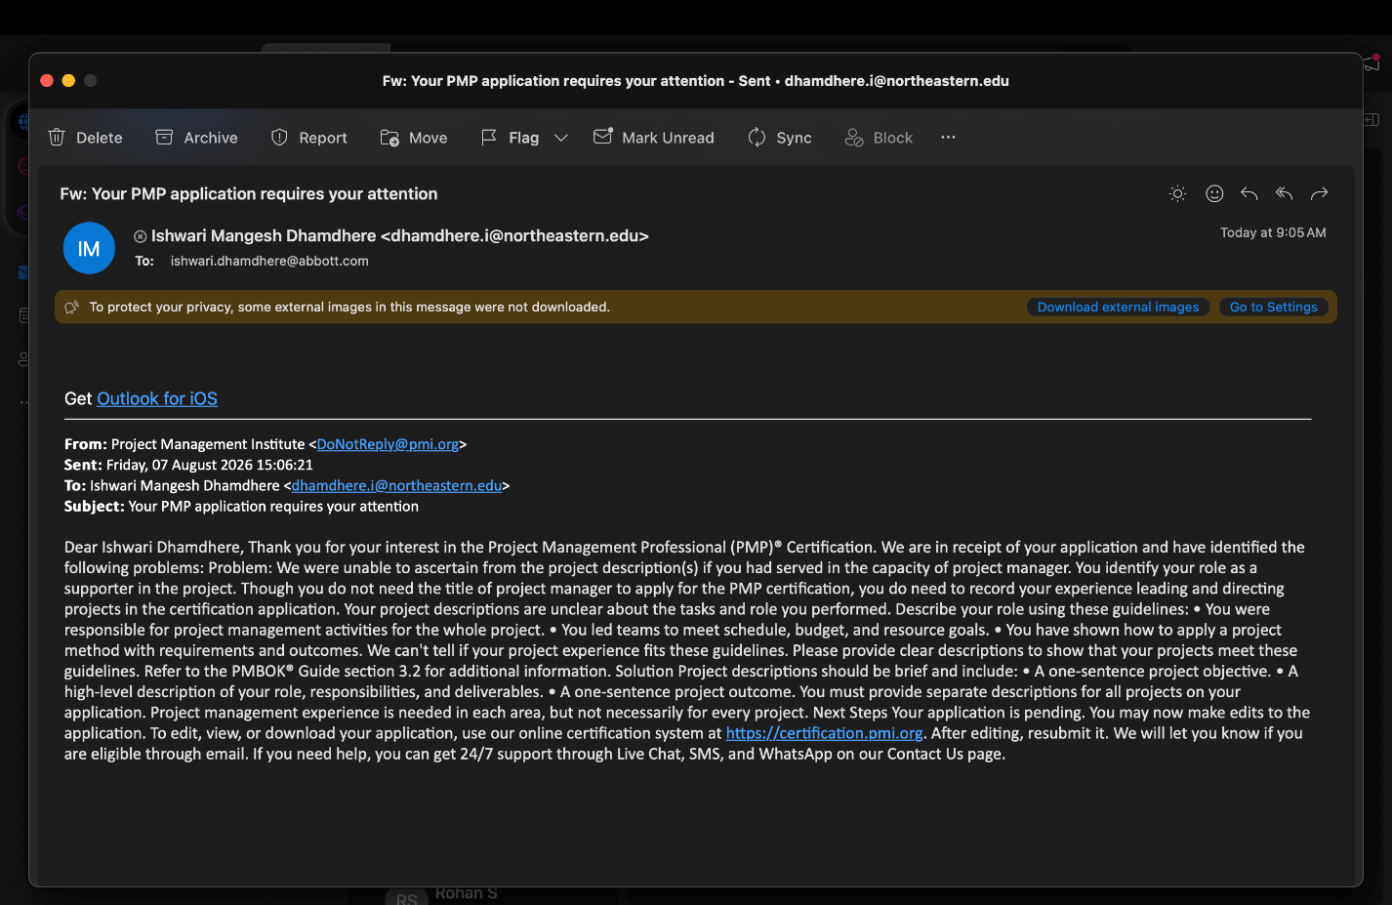

Abbott Nutrition, Columbus Ohio
Quality Assurance Project Specialist
May 2026- Present Project Title: Supplier Quality Change Management Project
Role: Quality Assurance Project Specialist
Supported supplier quality projects by managing documentation, change requests, and project deliverables across 15+ supplier accounts. Coordinated with Quality, Procurement, Operations, R&D teams, and external suppliers to execute supplier change initiatives within defined timelines.
Reviewed and processed supplier change requests using risk-based assessments to ensure compliance with FDA regulations, ISO 13485 requirements, and internal quality standards. Tracked project milestones, deliverables, action items, and risks to support timely completion of quality initiatives.
Developed and maintained project trackers, status reports, and supplier records using Excel and SharePoint to improve visibility, traceability, and reporting accuracy. Collaborated with stakeholders to resolve documentation issues, reduce delays, and maintain audit readiness.
Identified documentation risks and compliance gaps, supported corrective actions, and facilitated communication across teams to ensure successful implementation of supplier changes and quality improvements.

